East Down Yacht Club
50th Anniversary Mid-Summer Barbeque Weekend Celebrations
Sat 30th June / Sunday 1st July

SATURDAY 30th June - A fantastic fun filled family day of activities are planned.
10.30 – 11.30a.m. - A Team Kayak (short course ) relay race-50 Laps !!! ( In front of pontoon )
( All levels of competency welcome ---it’s the taking part that counts !! )
11.30 – 12.30 - Kayak water polo match ( In front of pontoon )
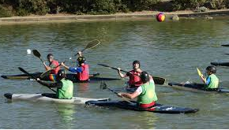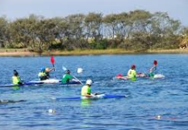
1.00p.m. FANCY DRESS PARADE ( For all ages !! - Children & Adults !! )
The THEME is either Vikings or Pirates
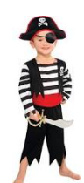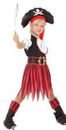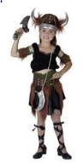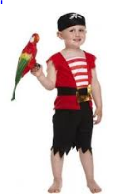
PRIZES will be awarded in various categories
1.30 – 2.30p.m. – Dressing your boat ready for “ The BIG Parade of sail “

3.00 p.m. – The Parade of Sail
This is our main event – It will be led by a “REAL” Viking longboat ….. Sailed & rowed by ‘Real’ Vikings
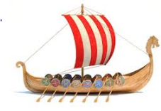
We want as many boats as possible all out on the water – Dressed out in flags / bunting / balloons etc., with their crews ‘dressed up as well’ ( Optional ….but preferable !! ) . From Kayak’s to Topper’s , Wayfarer’s , Leisure 17’s & Cruisers Small & Large representing the entire fleet. The flotilla will assemble at the mouth of the Dorn and come in down the Dorn ( Weather permitting - HW 3.30pm.) and pass by the front of the club to the accompaniment of Music & other celebrations !!
This will be followed by a display by the RNLI Inshore Lifeboat from Portaferry.

During the entire day there will be a small Viking Encampment in the grounds of the Clubhouse . They will be demonstrating Viking lifestyle / armaments / Cooking / children’s activities & staging a ‘mock’ battle. There will also be an opportunity for members to have a go out on the Viking longboat.

EVENING
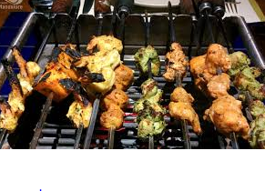
MID-SUMMER Barbeque at the rear of the Club.
Meat platters Can be purchased as usual from our catering team & the usual salads etc., will be available. There will be music & dancing following afterwards.

Sunday 1st June
A Sunday ‘brunch’ is planned
Followed by
The Commodore’s Cruise
Culminating in a 50th Anniversary afternoon tea & Cake !!!

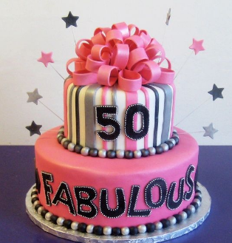

THE MOST IMPORTANT THING
PLEASE COME
and bring your friends and family to join in the celebrations
…..Get into the spirit of the weekend
……..and let’s all celebrate 50 FABULOUS years of Sailing at EDYC
===========

