Notes for EDYC RO 2021 version 5

Due to RRS rule change we cannot use flag V for a class flag – hence we will use flag T for the Dinghy II

Due to Covid – we seek flag movements to be conducted by one person – thus no hauling up and down at the same time point.

Warning signal times
CLASSES | Saturday | Wednesday
Cruiser 1 Handicap (PYS 1045 & under) | 1420 | 1920
Cruiser 2 Handicap (PYS 1046 & over) | 1423 | 1923
Dinghy 1 Handicap (PYS 1140 & under) | 1426(Race 1)  No later than 1545(Race 2) | 1926
Leisure 17 | 1429 | 1929
Dinghy 2 Handicap (PYS 1141 & over) | 1432(Race 1)  No later than 1548(Race 2) | 1932

Class flags shall be the following Code Flags:
Class | Code Flag
Cruiser 1 | H
Cruiser 2 | G
Dinghy 1 | W
Leisure 17 | B
Dinghy 2 | V now T
OTHER FLAGS
First Substitute, P, S – standard meanings

The RO will commence with seven flags raised on halyards and stick, flying and visible on the halyards well before 14:20, the AP flag will be used and fly on rear of committee boat on stick, no sound signals will have been made
The Autohoot will be set for 3 mn repetitive hoots
The warning signal for each succeeding class will be the starting signal of the preceding class. Except in the case of cruiser I where the warning signal is the lowering of the Blue flag. There are no preparatory signals.
At 14:17 the AP flag stick will be removed – auto hoot started
At 14:20 the Blue flag will be lowered – the warning signal for cruiser I
At 14:23 the H flag will be lowered the start signal for Cruiser I
Also this is the warning signal for Cruiser II
At 14:26 the G flag will be lowered the start signal for Cruiser II
Also this is the warning signal for Dinghy I
At 14:29 the W flag will be lowered the start signal for Dinghy I
Also this is the warning signal for Leisure 17
At 14:32 the B flag will be lowered the start signal for Leisure 17
Also this is the warning signal for Dinghy II
At 14:35 the T flag will be lowered the start signal for Dinghy II
All flags are on deck and auto hoot is turned off

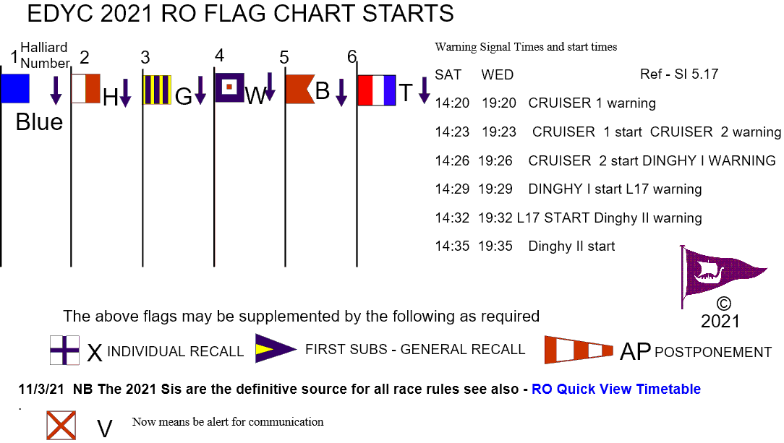

Flag V means Monitor communication channel for safety instructions (see rule 37).

